**Assignment 7.3**

1. **Hive Data Definitions**

Hive DDL statements are here, including:

* CREATE DATABASE/SCHEMA, TABLE, VIEW, FUNCTION, INDEX
* DROP DATABASE/SCHEMA, TABLE, VIEW, INDEX
* TRUNCATE TABLE
* ALTER DATABASE/SCHEMA, TABLE, VIEW
* MSCK REPAIR TABLE (or ALTER TABLE RECOVER PARTITIONS)
* SHOW DATABASES/SCHEMAS, TABLES, TBLPROPERTIES, VIEWS, PARTITIONS, FUNCTIONS, INDEX[ES], COLUMNS, CREATE TABLE
* DESCRIBE DATABASE/SCHEMA, table_name, view_name.

**Example:**

* hive**>** CREATE SCHEMA userdb;
* hive**>** SHOW DATABASES;
* hive**>** DROP DATABASE IF EXISTS userdb;
* hive> CREATE TABLE emp(emp_idint,emp_name String);

1. **Hive Data Manipulations**

Hive allows for the manipulation of data in HDFS using a variant of SQL.DML refers to "Data Manipulation Language", a subset of SQL statements that modify the data stored in tables.

To understand the Hive DML commands, let's see the demo table.

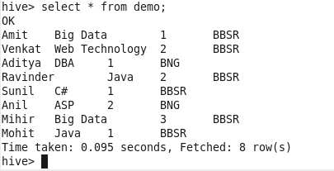

**Load data local inpath '/home/acadgild/emp_details.txt' overwrite into table demo ;**

**select skill,count(emp_name) from demo group by skill;**

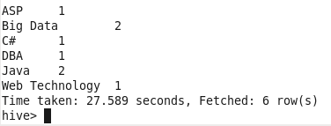

1. **HiveQL Manipulations**

HiveQL manipulations are same as data manipulatons instead of writng queries in hive shell, hiveql is file which contains executable queries which can be directly executed in the linux shell using

**hive –f /pathOfTheHiveqlFile**